Scroll down to page two to view image of “Seated Pigeon Twist”

**Seated Pigeon Twist**

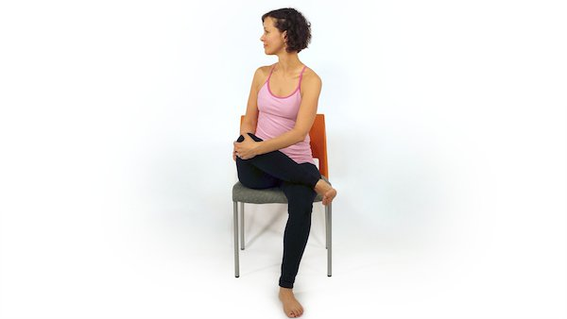

Inhale and draw your right leg up, resting your ankle on the left thigh and keeping the right foot flexed. Bring the right knee up a bit as you twist from the navel towards the right. Hold for 3 breaths. Do the same for the left side.

**SEATED PIGEON:**

A great hip opener!

* Plant your left leg on the floor and cross your right ankle to the left knee, feeling the stretch in the outer hip
* To increase the sensation, you can bend forward
* For those who are taking care of their knee or have less mobility through the knee joint: lift up the right leg, bending at the knee and hugging your knee toward your body to the point of gentle tension
* **Hold for 3-5 breath cycles and repeat other side**

**Benefits**: This pigeon opens your hips and lengthens your spine.

Chair yoga can be a gentle introduction to asana, a wonderful addition to senior activity, or a new perspective for your own practice. This yoga hybrid can bring about new body mindfulness for both beginners and advanced yogis alike.